*Florida International University*

*School of Computing and Information Sciences*

Software Engineering Focus

Feature Document

User Story ID <672 Local Database>

**Name:Bertha M Perez**

**Team Member(s): Bertha M Perez**

**Frank Hernandez**

**Project: Snackability 1.0**

**Product Owner(s)**: Dr. Cristina Palacios

**Mentor(s)**: Dr. Cristina Palacios

**Instructor**: Masoud Sadjadi

**User Story Name:** 672 Local Database

### **Description:**

* As an Admin I would like to be able to add snacks on campus to the database so that the database would be updated with all the products on campus

**Acceptance Criteria:**

1. Define Schema for the local database that will include nutrition values and score
2. Define test scripts

### **Related Tasks:**

* Creation of Snack database

**Use Case**

|  |  |
| --- | --- |
| Use Case Name: Add a new snack | |
| Participant Actor: Admin | |
| Entry Condition:   * Admin received an email reporting about a new item found on a vending machine that does not exist either in the local database or the USDA database | |
| Exit Condition: New snack is added to the database | |
| **Flow of Events** | |
| **Actor Steps** | **System Steps** |
| 1.Admin access the webpage and click Add Snack  3. Admin fill out the information and submit  7. Admin confirm the information | 2. System display form to add a snack  4. System submit the information for validation  5.System accept the information  6.System ask the admin for confirmation  8. App send the request to the system  9. System add snack  10. App show the information of the new snack and a message indicating that is already on the database |
|
| **Use Case Exceptions** | |
| **Actor Steps** |  |
| 3.3. Admin fill out the information and submit. [any of the field does not meet the requirements] | [any of the field does not meet the requirements]  System indicate which field does not meet the requirement and offers a 2nd try as well as canceling the whole use case |

**Use Case Diagram**

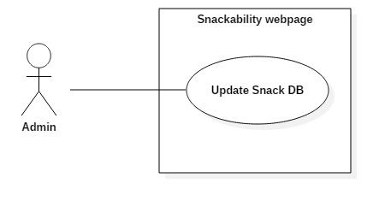

**Sequence Diagram**

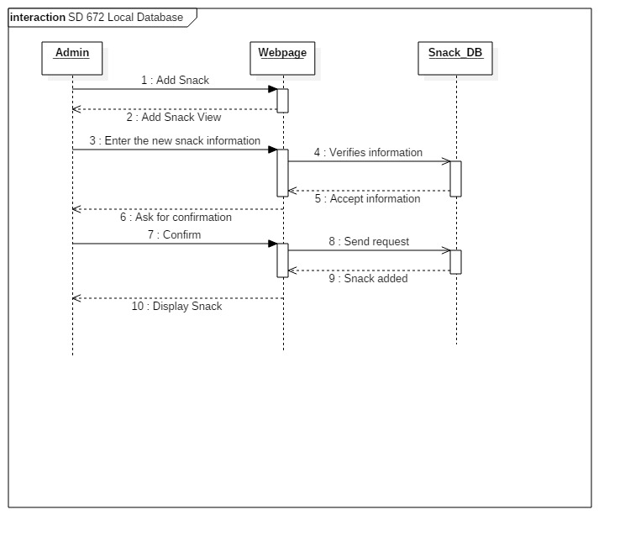

**Class Diagram**

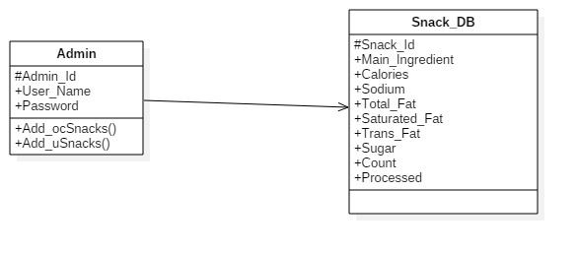

**Unit Test**

* Test case ID:insert_snack_ID
* Description/Summary of Test: Given a snack name and nutrition values, when the admin click Insert then the server should return the page with confirmation of insert
* Pre-condition: N/A
* Expected Results: Server return the page with confirmation of insert
* Actual Result: Confirmation page inserted
* Status (Fail/Pass): Pass

**Integration Test**

**Visual User Guide** <like one or two screenshots of the feature. For the hardware project, a photo of device is required>